
Danmarks Tekniske Universitet
Department of Civil Engineering

Multi-Sample Comparison Report
Hydraulic Conductivity Analysis - 15 Samples
Project: DTU Sustiain
Date: June 29, 2026

Multi-Sample Comparison Report
Project | DTU Sustiain
Report Date | June 29, 2026 at 13:31
Number of Samples: 15
Temperature: 20 °C
Porosity: Varies by sample (0.26 to 0.435)

Executive Summary
Comparison Analysis: This report compares 15 soil samples based on grain size distribution and hydraulic conductivity estimates.
Key Findings:
- Highest permeability: Sample_1_Odong (9.54e-04 m/s)
- Lowest permeability: Example_2_Case_1_Vukovic_15C (1.14e-06 m/s)
- Permeability range: 837.4x difference

Methodology

Comparative Analysis Approach
This comparison report presents a side-by-side analysis of multiple soil samples to identify patterns, variations, and relationships between grain size characteristics and hydraulic conductivity estimates.

Analysis Components
Grain Size Comparison: Overlapping distribution curves allow visual assessment of particle size variations between samples.
K-Value Comparison: Box plots and statistical summaries reveal the range and reliability of hydraulic conductivity estimates across samples.
Method Reliability: A reliability matrix shows which empirical methods are applicable for each sample, helping identify the most suitable estimation approaches.

Results & Analysis

Sample Overview
Sample | Temp (?C) | Porosity | D10 (mm) | D50 (mm) | D60 (mm) | Cu
Example_1_Case_1_Vukovic | 20.00 | 0.384 | 0.150 | 0.485 | 0.550 | 3.67
Example_1_Case_2_Vukovic_15C | 20.00 | 0.384 | 0.150 | 0.480 | 0.550 | 3.67
Example_2_Case_1_Vukovic_15C | 20.00 | 0.26 | 0.014 | 0.210 | 0.300 | 21.43
Sample_1_Odong | 20.00 | 0.346 | 0.341 | 1.181 | 1.886 | 5.53
Thomson_SERDP_Borden_Sand | 20.00 | 0.407 | 0.070 | 0.180 | 0.195 | 2.79
NBAL-01 [English] | 20.00 | 0.435 | 0.171 | 0.295 | 0.319 | 1.86
NBAL-02 [English] | 20.00 | 0.399 | 0.255 | 0.655 | 0.785 | 3.08
NBAL-03 [English] | 20.00 | 0.405 | 0.122 | 0.305 | 0.350 | 2.86
NBAL-04 [English] | 20.00 | 0.35 | N/A | 0.173 | 0.205 | N/A
NBAL-05 [English] | 20.00 | 0.419 | 0.098 | 0.192 | 0.233 | 2.38
NBAL-06 [English] | 20.00 | 0.421 | 0.257 | 0.526 | 0.592 | 2.30
NBAL-07 [English] | 20.00 | 0.425 | 0.219 | 0.425 | 0.473 | 2.16
NBAL-08 [English] | 20.00 | 0.423 | 0.125 | 0.244 | 0.281 | 2.25
NBAL-09 [English] | 20.00 | 0.432 | 0.164 | 0.297 | 0.325 | 1.97
NBAL-10 [English] | 20.00 | 0.394 | 0.178 | 0.516 | 0.583 | 3.27
Sample | Soil type | K geometric mean (m/s)
Example_1_Case_1_Vukovic | Poorly-graded sand | 2.73e-04
Example_1_Case_2_Vukovic_15C | Poorly-graded sand | 2.74e-04
Example_2_Case_1_Vukovic_15C | Well-graded sand | 1.14e-06
Sample_1_Odong | Poorly-graded sand | 9.54e-04
Thomson_SERDP_Borden_Sand | Poorly-graded sand | 5.01e-05
NBAL-01 [English] | Poorly-graded sand | 3.64e-04
NBAL-02 [English] | Poorly-graded sand | 7.45e-04
NBAL-03 [English] | Poorly-graded sand | 1.94e-04
NBAL-04 [English] | Sand | 8.50e-05
NBAL-05 [English] | Poorly-graded sand | 1.21e-04
NBAL-06 [English] | Poorly-graded sand | 8.28e-04
NBAL-07 [English] | Poorly-graded sand | 6.05e-04
NBAL-08 [English] | Poorly-graded sand | 1.94e-04
NBAL-09 [English] | Poorly-graded sand | 3.38e-04
NBAL-10 [English] | Poorly-graded sand | 4.18e-04

Grain Parameters Comparison
Large table moved to companion Excel appendix: Grain Parameters Comparison.

K-Value Aggregate Summary
Scope | Datasets | Geometric mean (m/s) | Arithmetic mean (m/s) | Median (m/s) | ln(K) std dev
Overall | 15 | 2.49e-04 | 4.88e-04 | 3.02e-04 | 1.525
test | 3 | 3.98e-04 | 6.39e-04 | 3.44e-04 | 0.931
test2 | 2 | 1.15e-05 | 4.10e-05 | 3.41e-05 | 2.261
test3 | 7 | 3.44e-04 | 5.53e-04 | 3.99e-04 | 1.060
test4 | 3 | 3.01e-04 | 3.97e-04 | 2.73e-04 | 0.716
Scope | Included K cells | Warning cells | Permeability class
Overall | 188 / 240 | 52 | High (Clean Sand)
test | 40 / 48 | 8 | High (Clean Sand)
test2 | 18 / 32 | 14 | Moderate (Fine Sand)
test3 | 89 / 112 | 23 | High (Clean Sand)
test4 | 41 / 48 | 7 | High (Clean Sand)

K-Value Calculations by Dataset and Method
Large table moved to companion Excel appendix: K-Value Calculations by Dataset and Method.

Permeability Classification Summary
Sample Name | K geometric mean (m/s) | Classification
Example_1_Case_1_Vukovic | 2.73e-04 | High (Clean Sand)
Example_1_Case_2_Vukovic_15C | 2.74e-04 | High (Clean Sand)
Example_2_Case_1_Vukovic_15C | 1.14e-06 | Low (Silt)
Sample_1_Odong | 9.54e-04 | High (Clean Sand)
Thomson_SERDP_Borden_Sand | 5.01e-05 | Moderate (Fine Sand)
NBAL-01 [English] | 3.64e-04 | High (Clean Sand)
NBAL-02 [English] | 7.45e-04 | High (Clean Sand)
NBAL-03 [English] | 1.94e-04 | High (Clean Sand)
NBAL-04 [English] | 8.50e-05 | Moderate (Fine Sand)
NBAL-05 [English] | 1.21e-04 | High (Clean Sand)
NBAL-06 [English] | 8.28e-04 | High (Clean Sand)
NBAL-07 [English] | 6.05e-04 | High (Clean Sand)
NBAL-08 [English] | 1.94e-04 | High (Clean Sand)
NBAL-09 [English] | 3.38e-04 | High (Clean Sand)
NBAL-10 [English] | 4.18e-04 | High (Clean Sand)

Grain Size Distribution Comparison
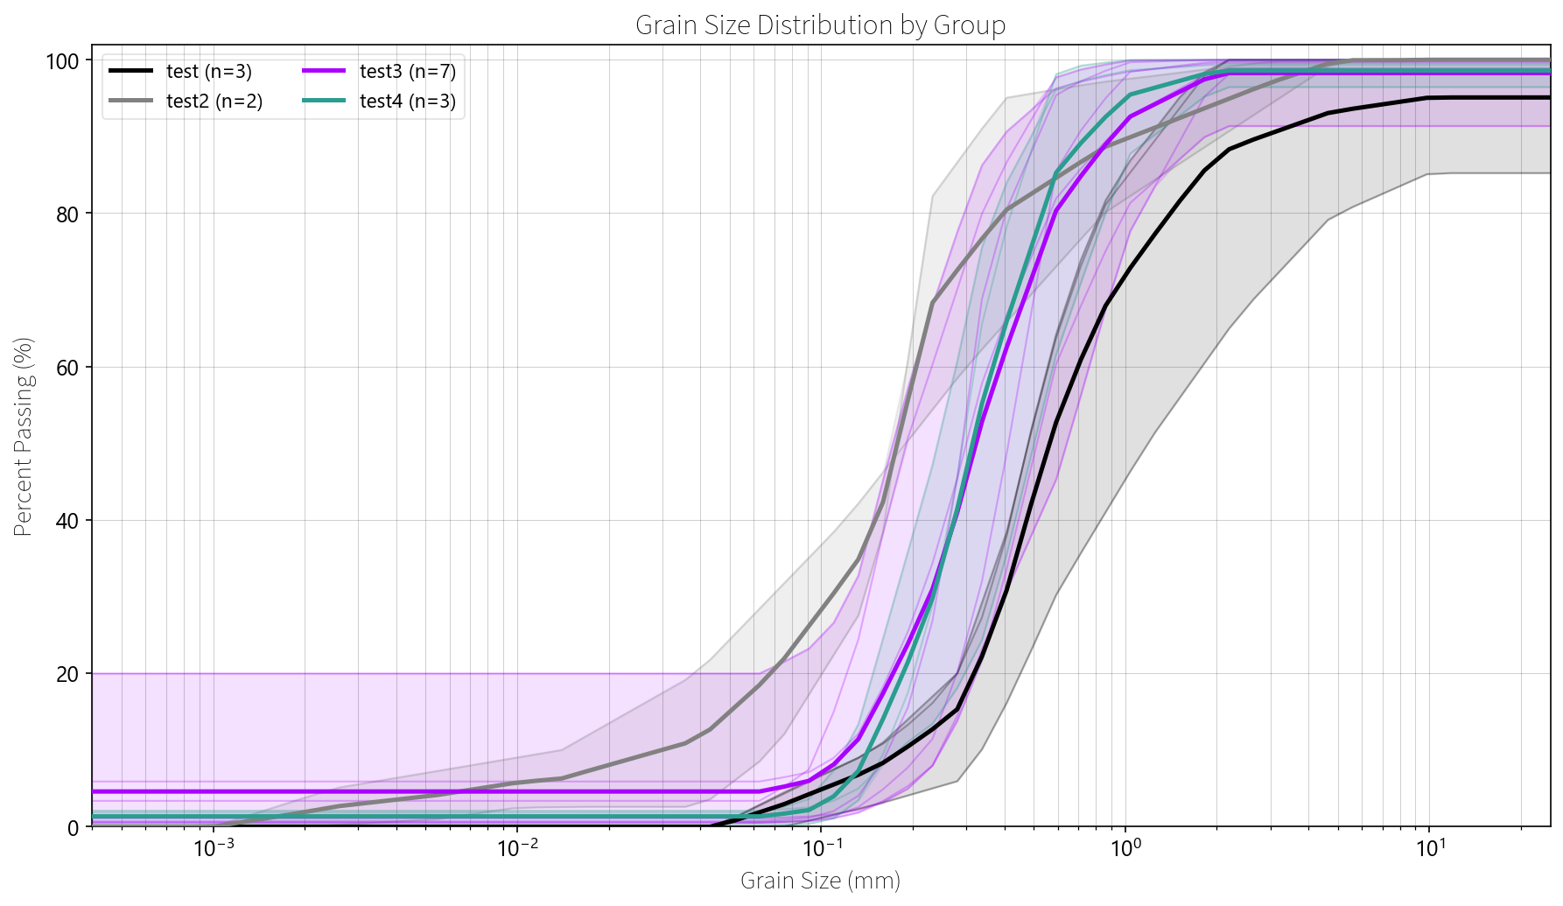

Hydraulic Conductivity by Method
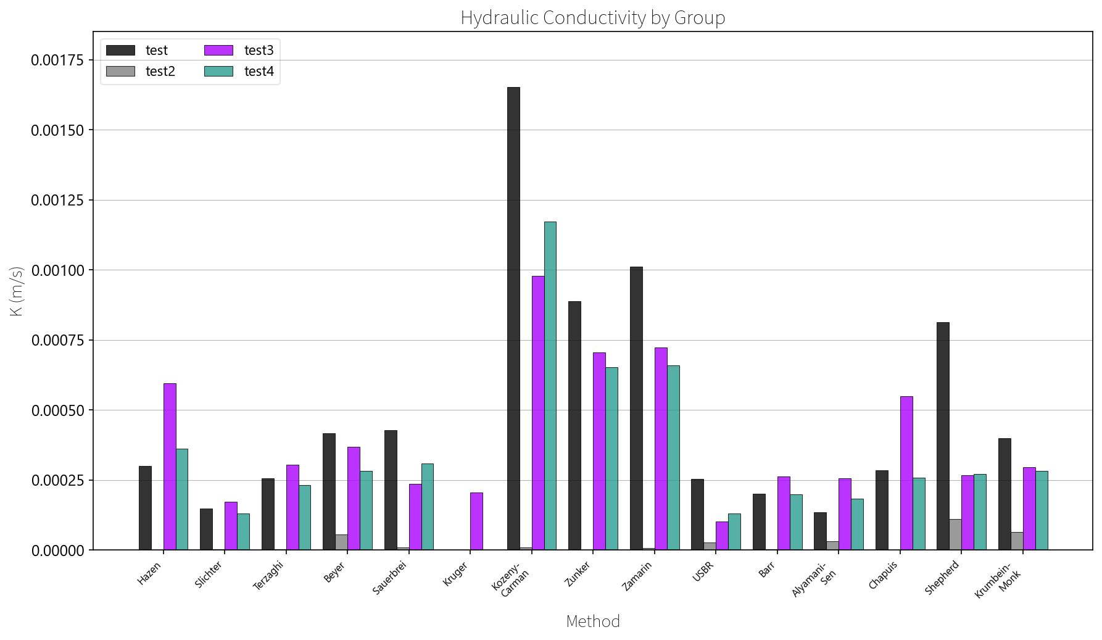

Hydraulic Conductivity Distribution
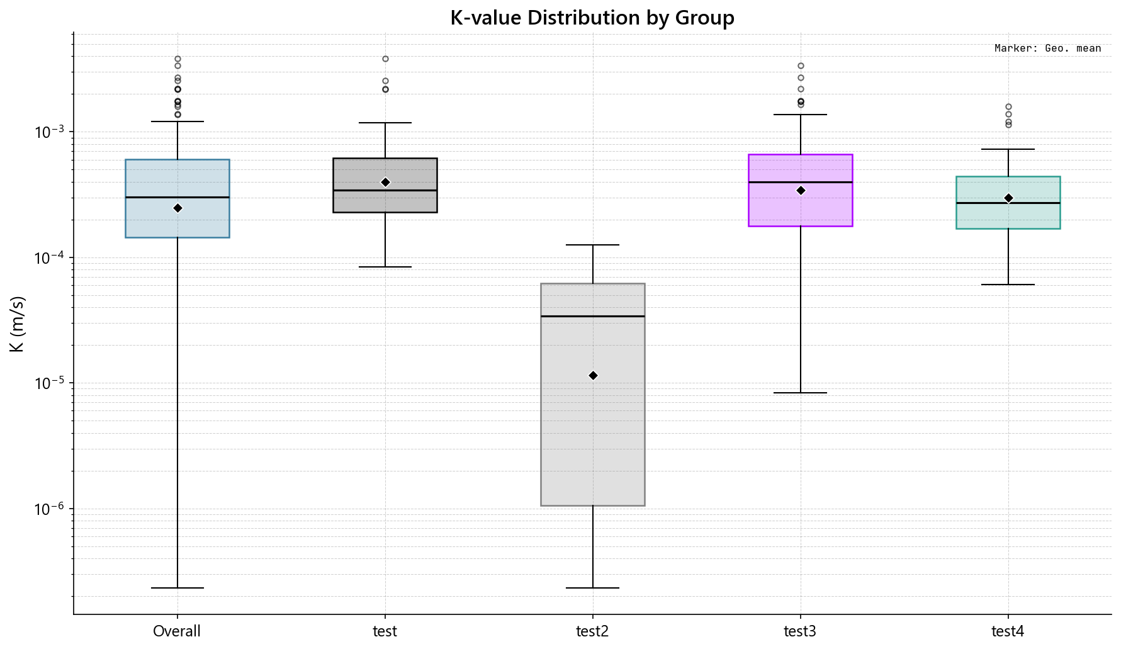

Interpretation & Discussion

Comparative Analysis
Permeability Characteristics:
- The highest permeability sample is Sample_1_Odong with K = 9.54e-04 m/s, classified as High (Clean Sand).
- The lowest permeability sample is Example_2_Case_1_Vukovic_15C with K = 1.14e-06 m/s, classified as Low (Silt).
- The 837.4-fold difference in permeability reflects the variability in grain size distribution among the samples.
Statistical Overview:
- Average sample K geometric mean: 3.63e-04 m/s
- Standard deviation: 2.84e-04 m/s
- Coefficient of variation: 78.3%

